**Chunmei Zhu – CUNY Assessment Test Lesson Plan Sample**

**Objectives**

Students will do the following:

* Learn the exponential function and its properties
* Calculate the exponential functions
* Sketch graphs and analyst the properties of exponential function

**Materials**

The class will need the following:

College-Level Mathematics: Exponential function.

<http://www2.cuny.edu/academics/testing/test-preparation-resources/>

**Procedures**

1. Explain to students that the properties of exponential function, the difference of exponential function a power function.

*Definition*: In a power function the independent variable (x) is raised to a (constant) power (c),

. In an exponential function the independent variable (x) is the exponent while the base is a constant,. A more general formula is , where a,k,h are real numbers.

*Properties*: :

* The graph of will always contain the point (0,1). Or regardless of the value of b.
* For every possible b Note that this implies that.
* If then the graph of will decrease as we move from left to right. Check out the graph of below for verification of this property.
* If then the graph of will increase as we move from left to right. Check out the graph of below for verification of this property.
* If then x=y.

1. Show how to calculation three functions and sketch the graph :

-8

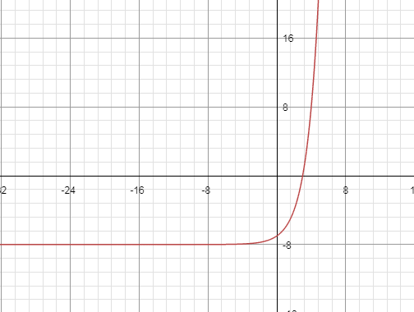

1. x domain : x is a real number ( -∞, +∞ )
2. y domain : y is a real number (-8, +∞)
3. the interceptor on x-axes: (3,0)
4. the interceptor of y-axes: (0,-7)
5. What is the graph look like: y increasing while x increasing -> increasing curve

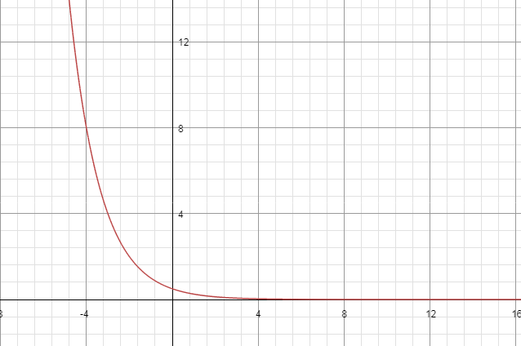

1. x domain : x is a real number ( -∞, +∞ )
2. y domain : y is a real number (0, +∞)
3. the interceptor on x-axes: y>0, no intercept on x-axes
4. the interceptor of y-axes: (0,0.5)
5. What is the graph look like: y decreasing while x increasing -> decreasing curve above x-axes

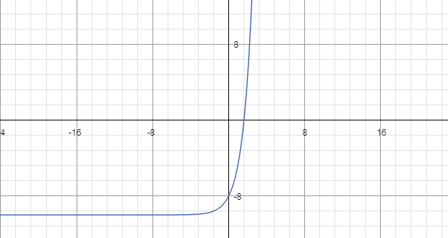

1. x domain : x is a real number ( -∞, +∞ )
2. y domain : y is a real number (-10, +∞)
3. the interceptor on x-axes: (1.60944,0)
4. the interceptor of y-axes: (0,-8)
5. What is the graph look like: y increasing while x increasing -> increasing curve

**Practical Questions**

Q1. , and answer the question in discussion section

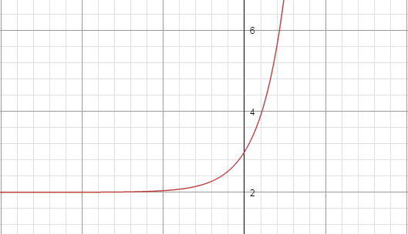

1. x domain : x is a real number ( -∞, +∞ )
2. y domain : y is a real number (2, +∞)
3. the interceptor on x-axes: y>0, no intercept on x-axes
4. the interceptor of y-axes: (0,3)
5. What is the graph look like: y increasing while x increasing -> increasing curve and above x=2

Q2. , and answer the question in discussion section

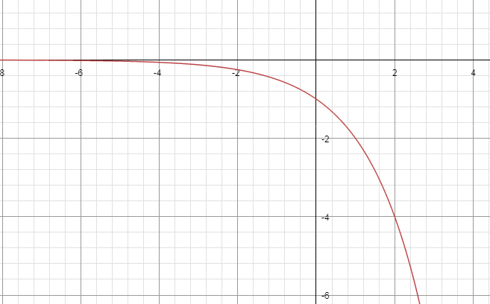

1. x domain : x is a real number ( -∞, +∞ )
2. y domain : y is a real number (-∞, 0)
3. the interceptor on x-axes: y<0, no intercept on x-axes
4. the interceptor of y-axes: (0,-1)
5. What is the graph look like: : y decreasing while x increasing -> decreasing curve below x-axes

Q3. , and answer the question in discussion section

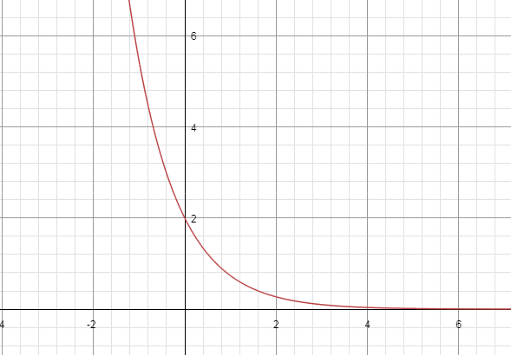

1. x domain : x is a real number ( -∞, +∞ )
2. y domain : y is a real number (0, +∞)
3. the interceptor on x-axes: y>0, no intercept on x-axes
4. the interceptor of y-axes: (0,2)
5. What is the graph look like: : y decreasing while x increasing -> decreasing curve above x-axes

Q4., and answer the question in discussion section

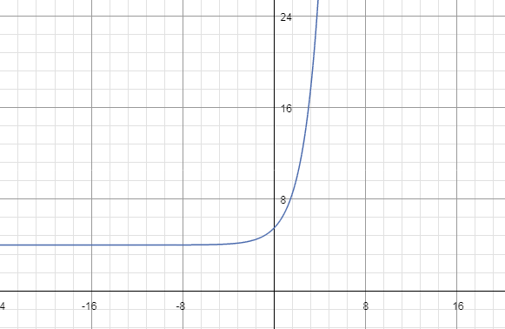

1. x domain : x is a real number ( -∞, +∞ )
2. y domain : y is a real number (0, +∞)
3. the interceptor on x-axes: y>4, no intercept on x-axes
4. the interceptor of y-axes: (0,5.5)
5. What is the graph look like: : y decreasing while x increasing -> decreasing curve above x=4

**Discussion**

1. What is the domain of the independent variable (x)?
2. What is the domain of the dependent variable (y)?
3. What is the interceptor on x-axes?
4. What is the interceptor on y-axes?
5. What is the graph look like?

**Evaluation**

* Each answer in discussion : 1 point (x5)
* Sketch a graph: 2 points
* Each problem has 7 points in total

**Extensions**

Tips for sketching a two-dimension graph for a function:

* Analyst the character of the function: input and output domain, central point,
* List the value of the independent-single variable
* Use calculator to computer the dependent variable
* Plot the points in a graph
* Connect the points
* Descript the graph – the relationship of independent variable and dependent variable, center point

**Suggested Readings**

Resources of CUNY Assessment Test in Math

<http://www2.cuny.edu/academics/testing/test-preparation-resources/>

**Vocabulary**

Power

Base

Domain

Independent variable x

Dependent variable y

Curve in a two-dimension graph

Interception point